**SECD 2613-15 SYSTEM ANALYSIS AND DESIGN**

**20232024 – SEMESTER 2**

**PHASE 1**

**Books Exchange platform**

**FACULTY OF MJIIT**

**GROUP 6**

|  |  |
| --- | --- |
| **NAME** | **MATRIC ID** |
| **Kahlan Sultan Mohammed** | **A23MJ4021** |
| **Liu Ruoyang** | **A23MJ4022** |
| **Buguoshun** | **A23MJ4019** |

**1.Executive Summary:**

Our proposed "Book Exchange Platform" aims to alleviate the financial burden of textbooks for students amidst the rising costs of education. Students can buy, sell, or exchange textbooks and course materials with their peers, bypassing costly intermediaries. Key features include secure transactions, cost savings, and environmental sustainability. This platform not only meets students' needs but also fosters community and sustainability. With sponsorship support, our goal is to revolutionize access to course materials globally.

**2.Background:**

Although our organization is newly established, we are fully capable of addressing the issue of expensive textbooks for students. We recognize the fatigue students experience in dealing with escalating education costs, hence, we saw an opportunity to create a centralized platform for textbook transactions. Leveraging technology makes us pioneers in textbook accessibility.

**3.Objectives:**

a. *Increase Accessibility*: Provide students with a convenient platform to access affordable textbooks and course materials.

b. *Alleviate Financial Pressure:* Reduce students' financial burden by offering cost-effective options for textbooks.

c. *Promote Community Engagement:* Cultivate an inclusive environment for students to connect and collaborate.

These objectives reflect our vision of educational equity and student success, aiming to create a global learning environment that is open, inclusive, sustainable, and collaborative.

**4.Methodology:**

Our method to accomplish these Objectives will contain collaborative design and development phases:

a.*Market research:*

. Who are we trying to reach?

. Narrow down the ideal users (think college students or high school students).

. Figure out what matters to them when it comes to sharing and swapping books. What are their challenges and desires?

. Check out the Competition:

. See what other book swapping platforms are out there, both general and focused on specific interests.

. Take a deep dive: what features do they offer? How easy are they to use? What do they do well, and what could be improved?

. Find the gaps! Is there something missing that we can offer to stand out?

b.*Technical Planning:*

. Pick the right tools: Decide on technologies for the app, website, and data storage.

. Cloud or our own servers? Choose how to run the platform based on growth, security, and upkeep.

. Design the database: Set up how information is stored for users, books, and activity.

. Security first: Plan protections like encryption and user logins to keep data safe.

c.*Platform Feature Planning:*

. Let’s build what students need first! Using what we learned from research and student feedback, we'll focus on the most important features for the book exchange platform.

. This might include things like creating profiles, listing books, searching and filtering options, messaging with other students, leaving reviews, and getting notified about activity.

d. *Development and Testing:*

. Use Agile for flexible development with feedback.

. Build the user interface with HTML, CSS, and frameworks.

. Implement server logic, database, and APIs.

. Test for functionality, performance, and reliability.

. Fix bugs found during testing to keep quality.

e.*Launch and Promotion:*

. Try out the platform with a small group first.

. Make a marketing plan for online (social media) and offline (flyers) channels. Partner with student groups.

. Throw a launch party with discounts to get people excited.

. Help users learn the platform with tutorials and support.

**5.Resources:**

I. Web Development Tools.

ii. Hosting Service.

iii. Database.

iv. Security Measures.

v. User Interface Design Tools.

vi. Testing Tools.

vii. Training materials and documentation.

viii. Marketing and Promotion

**6.Budget:**

I. *Web Development Tools:*

Front-end development (HTML, CSS, JavaScript): Free.

Frameworks (React.js, Angular, etc.): Free.

Back-end development (Node.js, Django, Ruby on Rails, etc.): Free.

ii. *Hosting Service:*

AWS, Azure, Google Cloud Platform, Heroku: Costs vary depending on usage.

Estimate around $50-$100 per month for a small-scale platform.

iii. *Database:*

MySQL, PostgreSQL, MongoDB: Free, though hosting costs may apply depending on the chosen service provider.

Estimate around $20-$50 per month for a small-scale platform.

iv. *Security Measures:*

SSL certificate: Costs vary, but you can get one for around $10-$100 per year.

Implementing security measures: Free (but may require additional development time)

v. *User Interface Design Tools:*

Adobe XD, Sketch, Figma: Pricing varies, but Figma offers a free tier for individuals.

vi. *Design and testing Tools:*

Jest, Selenium, Postman: $0 to $50 per month.

vii. *Training materials and documentation:*

This can cost up to $1000 per year.

viii. *Marketing and Promotion:*

Costs vary widely depending on the chosen marketing channels. Allocate a budget for advertising, content creation, and promotional activities.

Estimate around $200-$500 per month for a small-scale marketing campaign.

*

Adding up these estimates for a small-scale book exchange platform:

. Hosting & Database: $80-$140 per month.

. Design & Testing Tools: Minimal, assume $0-$50 per month.

. Marketing & Promotion: $300-$500 per month.

. Training materials and documentation: $1000 per year.

. Marketing and Promotion: around $250-$500 per month.

This totals to approximately $730-$1270 per month for running and maintaining the platform.

**7.Measurement and Reporting**

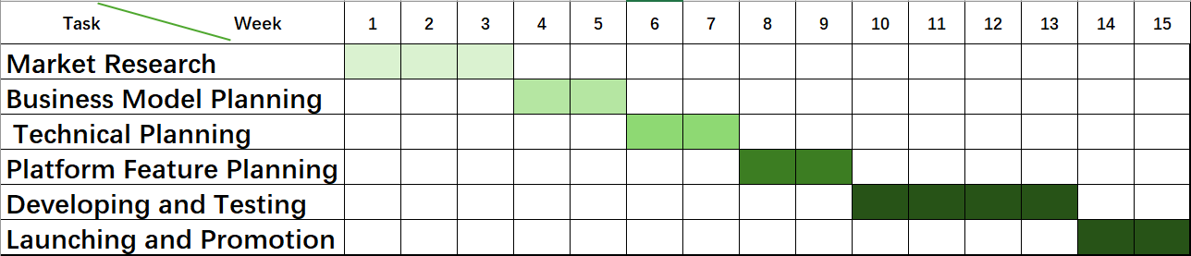

We will use a *Gantt chart* to track key phases such as Market Research, Technical Planning, Platform Feature Planning, Development and Testing, and Launch and Promotion. Bi-weekly progress reports will cover completed tasks, upcoming milestones, and any issues across these stages. Regular meetings with stakeholders will ensure alignment and address feedback.

**8.Risks**

>>Inaccurate market orientation may result in revenue falling short of expectations.

>>Incomplete technical planning may result in incomplete platform functionality.

>>Incomplete troubleshooting may lead to frequent platform bugs.

Mitigation strategies include thorough testing, stakeholder engagement, and adherence to best practices for data security and privacy